**Concise Summary Memo**

**Power BI Interactive Dashboard**

[**https://app.powerbi.com/groups/me/reports/0e063933-fef6-4daa-a435-0d58dcca20b6/20d9865034acea96453a?experience=power-bi**](https://app.powerbi.com/groups/me/reports/0e063933-fef6-4daa-a435-0d58dcca20b6/20d9865034acea96453a?experience=power-bi)

**Objective:**

* To develop a predictive model that forecasts the likelihood of societal unrest one month in advance across 50 regions using economic, environmental, and sociopolitical indicators.

**Approach & Methodology:**

* Data Preparation:
  + Dataset: unrest.csv
  + Handled missing values and performed basic feature engineering (e.g., extracting month/year).
  + Visualized class distribution and correlation with target (unrest_event).

**Model Development:**

* Target variable: unrest_event (binary classification).
* Features: All other relevant indicators, excluding identifiers and temporal fields.
* SMOTE was applied to balance the class distribution.
* Model: RandomForestClassifier within a pipeline (with StandardScaler).
* Training/Test Split: 70/30 stratified.

**Model Evaluation:**

* Reported performance with:
  + classification_report
  + ROC AUC Score
  + Average Precision Score
* Feature importance was visualized to identify influential indicators.

**Model Calibration:**

* Used CalibratedClassifierCV (isotonic regression) to improve probability estimates.
* Compared uncalibrated vs calibrated models with calibration curves.

**Results:**

* The Random Forest model performed well with balanced class treatment via SMOTE.
* ROC AUC and precision-recall metrics indicated good discriminatory power.
* Top features were clearly identified through importance analysis.
* Calibration improved the reliability of probability predictions.

1. **Distibution of Unrest Events**

**[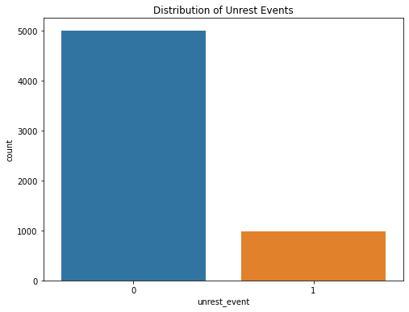](https://github.com/SanjibSaha27/Forecast_Probability_Social_Unrest/blob/main/1%20Distibution%20of%20Unrest%20Events.png)**

**2. Correlation with Unrest Event  [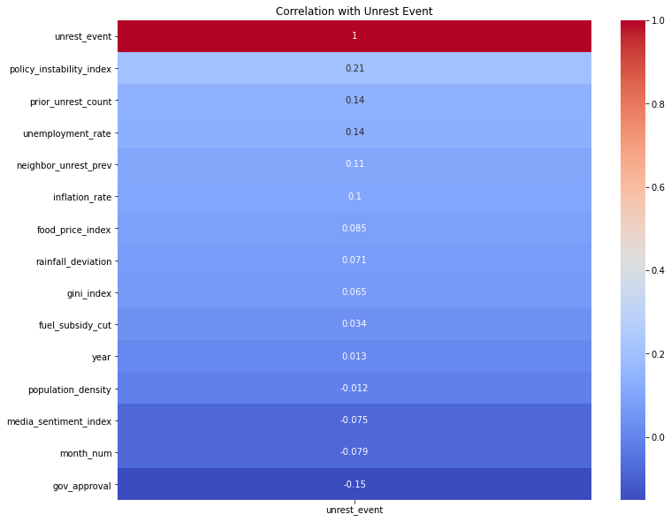](https://github.com/SanjibSaha27/Forecast_Probability_Social_Unrest/blob/main/2%20Correlation%20with%20Unrest%20Event.png)**

**[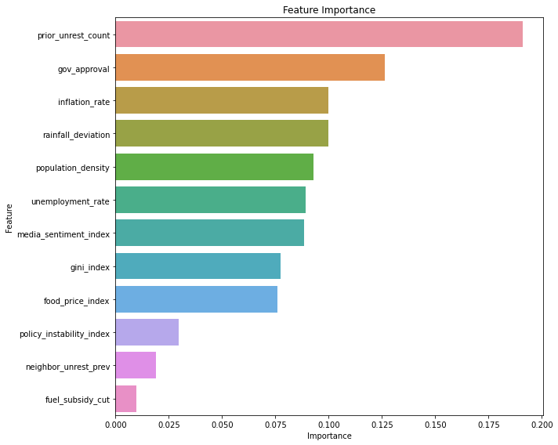](https://github.com/SanjibSaha27/Forecast_Probability_Social_Unrest/blob/main/3%20Feature%20Importance.png)3. Feature Importance**

**[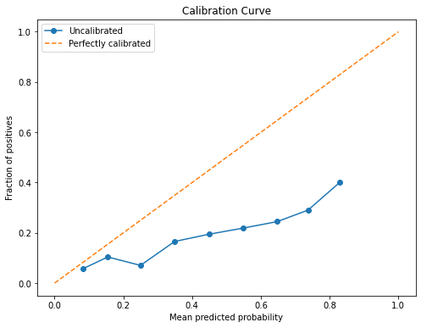](https://github.com/SanjibSaha27/Forecast_Probability_Social_Unrest/blob/main/4%20Calibration%20Curve.png)4. Calibration Curve**

**5. Calibration Curve Comparision [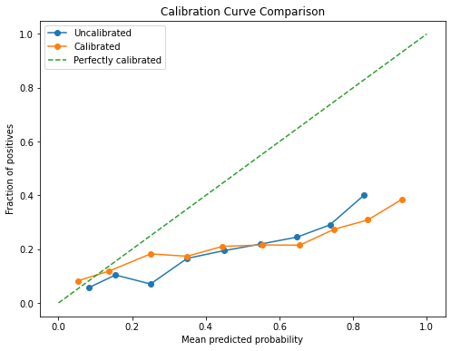](https://github.com/SanjibSaha27/Forecast_Probability_Social_Unrest/blob/main/5%20Calibration%20Curve%20Comparision.png)**

**Recommendations:**

* Use the calibrated model for more trustworthy risk probabilities in decision-making.
* Monitor the most important features over time for trend analysis.
* Incorporate real-time or updated data feeds for live prediction integration.
* Consider testing additional models (e.g., Gradient Boosting, XGBoost) for comparison.
* Explore temporal models (e.g., LSTM) if time sequence patterns are critical.

**Power BI Interactive Dashboard**

[**https://app.powerbi.com/groups/me/reports/0e063933-fef6-4daa-a435-0d58dcca20b6/20d9865034acea96453a?experience=power-bi**](https://app.powerbi.com/groups/me/reports/0e063933-fef6-4daa-a435-0d58dcca20b6/20d9865034acea96453a?experience=power-bi)